Quick Tips for using the Worker Training Program (WTP) Material Upload and Search Tool for Infectious Disease (MUSTID) Resource Portal
Created 7/21/2020
Updated 9/29/2021

MUSTID is a searchable portal that provides easy access to resources on infectious disease and worker safety shared by and relevant to the Worker Training Program (WTP) and others interested in worker safety and health. The current focus of this curated collection is coronavirus disease 2019 (COVID-19) and other infectious diseases such as severe acute respiratory syndrome (SARS), Middle East respiratory syndrome (MERS), and influenza.
This Quick Tips Guide provides user information on how to search MUSTID and what information is provided in the search results.

Searching MUSTID
You can search MUSTID using the Search Box located on the MUSTID Home page. You can either search for concepts by adding specific keywords to the Search Box or you can browse all the resources in MUSTID by clicking on the View All Resources button.
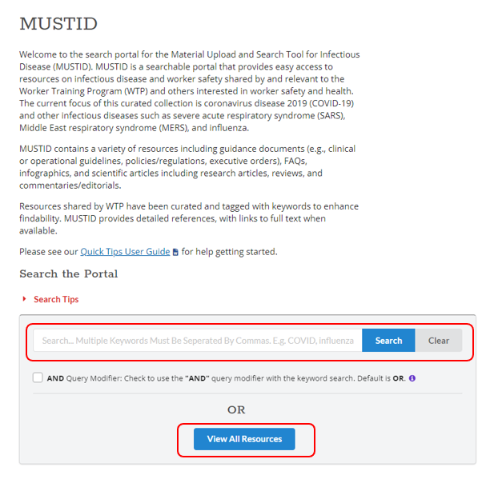

Tips for Using the Search Box
- The search function searches for keywords in the following text fields: Title, Resource Description, Source (Organization), Abstract, Resource Tags, and the full-text, if available.
- Separate multiple search terms with commas (e.g., COVID, respirator). Searching with multiple terms separated by commas will retrieve resources containing at least one of the terms in any of the text fields because the default operator is OR when the ‘AND Query Modifier’ box is not checked. For example, running the search for “COVID, respirator” without the ‘AND Query Modifier’ box checked retrieves 506 results. Each of these results will contain at least one of the search terms in the text fields.

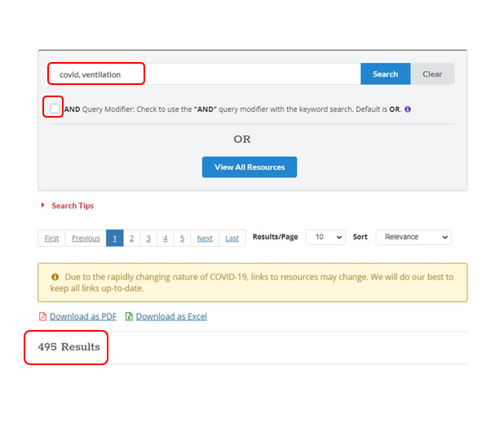

- To narrow your search so that your resources contain all search terms, check the ‘AND Query Modifier’ box under the Search Box. If you run the same search as above but check the ‘AND Query Modifier’ box, you only retrieve 196 results because now every resource contains both search terms.

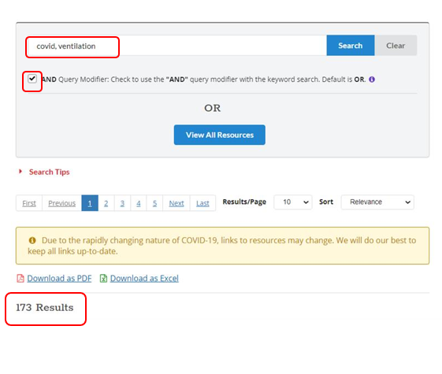

- Search terms will be highlighted in yellow in the search result display. If a record is retrieved but does not display highlighted keywords, then the search term was found in the associated full-text.

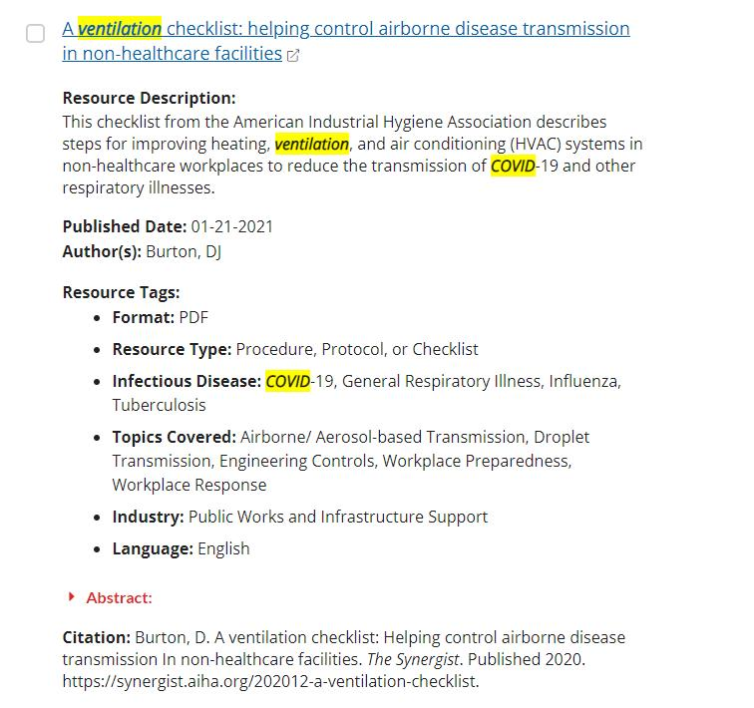

Search Results Display
The following information fields are included for each resource record: Title, Resource Description, Published Date, Author(s), Source (Organization), Resource Tags, Abstract, and Citation. Fields that do not contain data are not displayed.

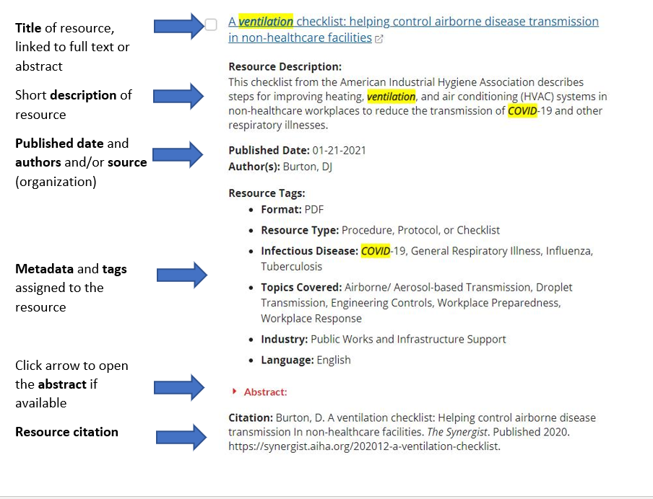

Exporting Results
Select one or more resources. Then download resources as a PDF or Excel file. The files will be in your computer’s downloads folder.

